**Project Design Phase-I**

**Solution Architecture**

|  |  |
| --- | --- |
| Date | 21 October 2022 |
| Team ID | PNT2022TMID03512 |
| Project Name | Project - Real-Time Communication System Powered by AI for Specially Abled |
| Maximum Marks | 4 Marks |

**PROPOSED SYSTEM ARCHITECTURE**

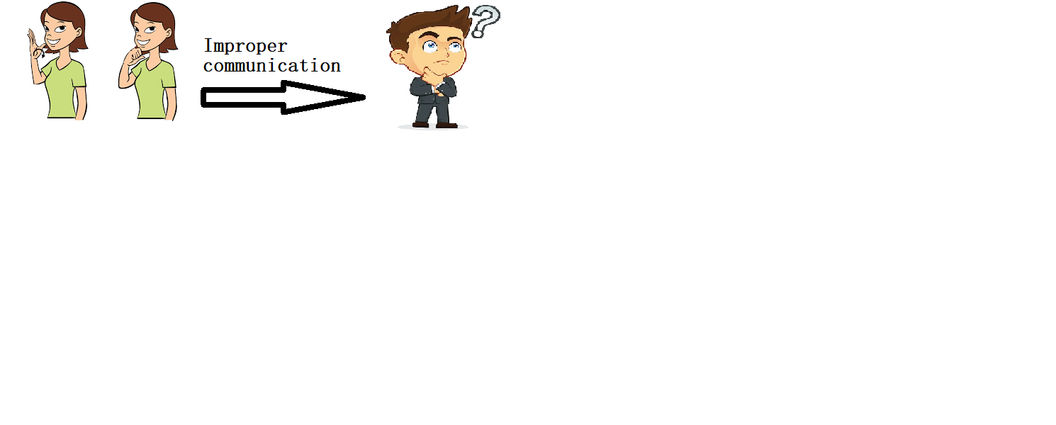

Capturing and storing the sign language

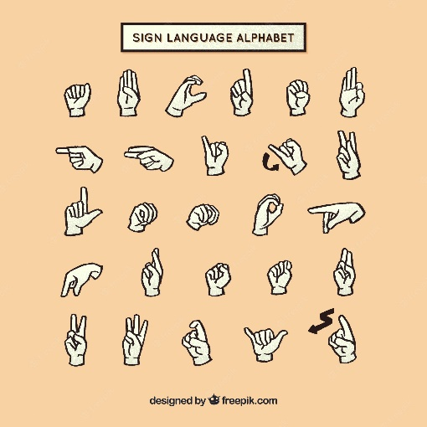

AI model to convert the sign language into text or audio